1.Write a query to display the orders placed by customer with phone number 030-0074321.

CREATE TABLE Orders

(

CustomerID int,

Customername varchar(20),

Phone_number int,

Products varchar(20),

Category varchar(20),

Place varchar(20)

);

Select * from Orders;

insert into Orders(CustomerID,Customername,Phone_number,Products,Category,Place)

values(1,'Mayur',0400074321,'milk','Drinks','Latur');

insert into Orders(CustomerID,Customername,Phone_number,Products,Category,Place)

values(2,'Swati',0300074321,'Chai','Drinks','Latur');

insert into Orders(CustomerID,Customername,Phone_number,Products,Category,Place)

values(2,'Sagar',0400074123,'Coca-cola','Drinks','London');

insert into Orders(CustomerID,Customername,Phone_number,Products,Category,Place)

values(2,'Mangesh',0500054143,'Fish','Seafood','Latur');

select * from Orders Where Phone_number='300074321';

C:\Users\Shital\Pictures\Screenshots\Screenshot (333).png

2.Fetching all the products which are available under Category ‘Seafood’.

select * from Orders Where Category='Seafood';

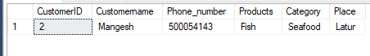

3. Display the orders placed by customers not in London.

select * from Orders Where Place='London';

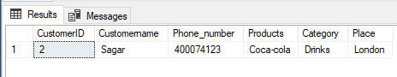

4.Selects all the order which are placed for the product Chai.

select * from Orders where Products='chai';

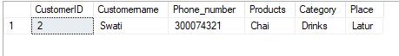

5.Write a query to display the name,department Name and rating of any given employee.

CREATE TABLE Emp

(

EmpID int,

Empname varchar(20),

Rating float,

);

select * from Emp

insert into Emp(EmpID,Empname,Rating)

values(1,'swati',4.9);

insert into Emp(EmpID,Empname,Rating)

values(4,'sonu',3.9);

insert into Emp(EmpID,Empname,Rating)

values(2,'Mangesh',4.5);

insert into Emp(EmpID,Empname,Rating)

values(3,'Dnyanu',3.9);

Name-select * from Emp Where Empname='swati';

C:\Users\Shital\Pictures\Screenshots\Screenshot (341).png

Rating-

Select * from Emp Where Rating=4.9;

select * from Emp Where EmpID=1;

C:\Users\Shital\Pictures\Screenshots\Screenshot (343).png